**BÀI ÔN KHỐI 4**

**BÀI ÔN 1**

1. **Look at the picture and answer the questions. (3pts)**

|  |  |
| --- | --- |
|  | 1. Do you ever go the cinema?   ….……………………………… |
|  | 1. What would you like?   ….………………………… |
|  | 1. What fruit is the biggest?   ….……………………………… |
|  | 1. Were there any buses twenty years ago?   ….……………………………….. |
|  | 1. Would you like some water?   ….…………………………… |
|  | 1. What is the biggest animal?   ….……………………………… |

**II. Read the text and choose the best answer.**

1. Did you enjoy the cinema?

A. Yes, I have.

B. Yes, I did.

C. Yes, I do.

2. What’s the name of the film?

A. It’s called Pirate Island.

B. It’s about pirates who find some treasure.

C. It was funny.

3. Was the film exciting?

A. Yes, it was.

B. Yes, I did.

C. Yes, it can.

4. Did you go with your friend Vicky?

A. No, she’s ten years old now.

B. No, she couldn’t come today.

C. Yes, she can play the piano.

5. Did you go by bus?

A. No, we went by train.

B. No, we went on Tuesday.

C. No, we can’t.

6. How often do you go to the cinema?

A. I go with my mother.

B. I go by bus.

C. I go every weekend.

**III. Look and read. Choose the correct words and write them on the lines. There’s one example**

A panda a puppy a bedroom socks a scarf a basement

1. You wear this on your neck when it is cold. …………………………..

2. This animal is a baby dog. …………………………..

3. You go to this room in a house to sleep. …………………………..

4. You wear these on your feet. …………………………..

5. You go downstairs to get to this part of a house under the ground ……………………..........

6. This big animal is black and white and can climb trees. ………………………….

**IV. Look and read. Write Yes or No:**

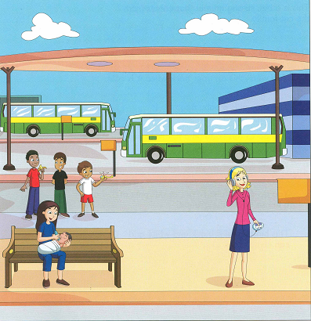

1. It is a rainy day. ……………….

2. There are three buses at the bus station. ……………….

3. The woman who is wearing a skirt is listening to her CD player. …………….

4. The woman with long hair is giving the baby a bottle of milk. ……………….

5. There are three boys behind the woman with the baby. ………………..

6. The tallest boy is drinking some orange juice. ………………..

7. The youngest boy is holding a toy helicopter. ………………..

8. Most people are dancing on the street ………………..

**BÀI ÔN 2**

1. **Write words to complete the sentences about the story. You can use 1,2 or 3 words.**

It was a very sunny morning on Friday. Fred got up, had breakfast with his brother, and then read his new comic and looked at all the pictures in it. Then he put his books and pens in his school bag and said” Goodbye” to his family. He rode his bike to school and put it next to the long wall there. All his friends’ bikes were there too.

Examples: On Friday, the weather was very sunny.

1. After breakfast, Fred looked at the pictures in his ………………………………….
2. Fred carried his ……………………………. To school in his school bag.
3. Fred went to school by …………………………….

Fred went to his classroom and sat down. He put his school books on the desk and took off his jacket because it was hot in the room. The room was very quiet because the teacher wasn’t there. No children were there, only Fred. Then he looked out of the window. He saw lots of people outside on the grass.

1. Fred put his …………………………………. On the desk when he sat down.
2. Fred didn’t want to wear his ………………………..because it was hot in the classroom.
3. Outside the window, there were …………………………… on the grass.
4. **Write in, on or at.**

1. ……….. the morning 2. …………… the afternoon

3. …………night 4. …………..Tuesday

5. ……….. 3 o’clock 6. …………. The evening

1. **Look at the pictures. Draw a line from the pictures to the correct words. (3pts)**

|  |  |  |
| --- | --- | --- |
|  | 1. She is kayaking. 2. Thanh is taking photos of monkeys. 3. He likes playing volleyball. |  |
|  |  |  |
|  | 1. They walk to school every day. 2. She isn’t playing football.   She is reading a book. |  |
|  |  |  |
|  | 1. Can I use your computer?   No, you can’t.   1. She is taking photos of penguins. |  |

1. **Look at the picture. Fill in the correct circle.**

|  |  |  |  |
| --- | --- | --- | --- |
|  |  | 1. She is swimming. 2. She isn’t kayaking. 3. They are windsurfing. |  |
|  |  | 1. Can you help me with my homework, please? 2. Can you turn off the TV? 3. Can you close the door, please? |  |
|  |  | 1. The park isn’t safe. 2. The park is clean. 3. The building is dangerous. |  |
|  |  | 1. They are windsurfing. 2. She is snorkeling. 3. They are sailing. |  |
|  |  | 1. Can you open the door? 2. Can you turn off the Cd player? 3. Can you turn off the TV? |  |
|  |  | 1. The river is clean. 2. The river is polluted. 3. The bridge is beautiful. |  |

**V. Look and read. Choose the correct words and write them on the lines. There’s one example.**

A clown a whale earache a kitten a hospital a doctor a football

Ex: This person is very funny: a clown

1. You go and see this person when you are not well. ……………………………..
2. This is a baby cat. ……………………………………….
3. You have this when your ears hurt. ………………………………………..
4. You go to this place when you are not well. …………………………………..
5. You kick a ball with your feet to play this sport. ……………………………….
6. This is the biggest animal in the world and it lives in the sea. …………………….

**BÀI ÔN 3**

**I/ Answer the questions:**

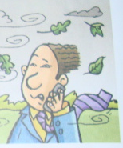

1. What’s the weather like?

……………………………………………….

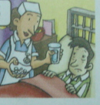

2. Where does she work?

……………………………………………….

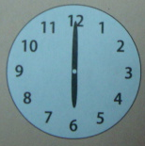 3. What time is it?

…………………………………………………..

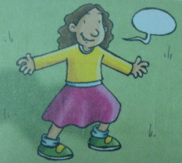 4. What’s she wearing?

…………………………………………………

**II/ Read the words. Write them in the correct boxes.**

Morning school balloons afternoon airport

Evening store candy fire station jacket

**PLACES**

School

………………………..

………………………..

………………………..

**PRESENTS**

..............................................................................................................................

**TIMES**

…………………………….

…………………………….

…………………………….

1. **Look at the pictures and write.**

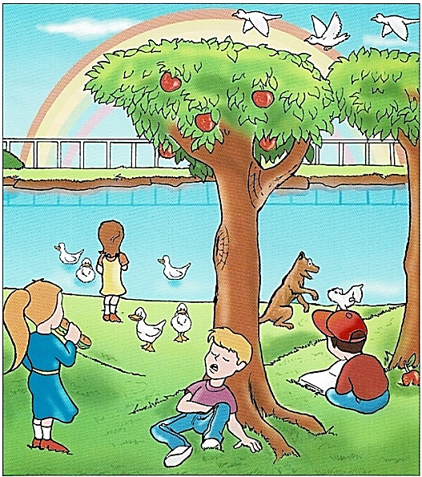

**Complete the sentences**

1. The boy wearing a hat is……………………………………………..
2. The girl eating a sandwich is wearing a……………………………….

**Answer the questions**

1. Where is the boy with the cap sitting?  
   ……………………………………………………………………………..
2. What are the birds doing?  
   ……………………………………………………………………………..

**Now write two sentences about the picture.**

1. ……………………………………………………………………………..
2. ……………………………………………………………………………..